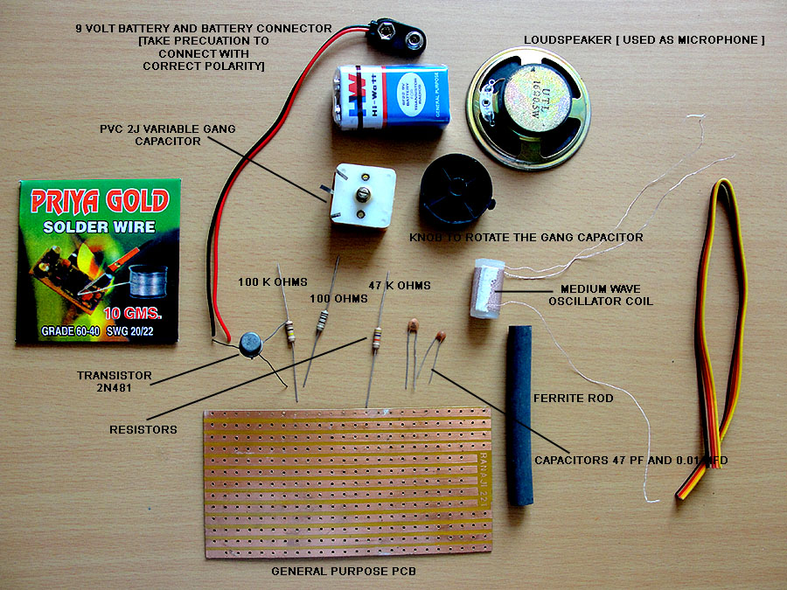

Components supplied with the
low power medium wave toy transmitter

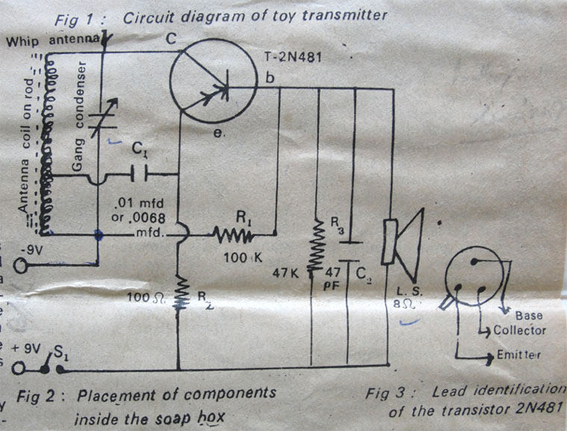

Circuit Diagram of the Toy Transmitter

This transmitter transmits near 1000 kHz. Frequency can be changed by turning the Variable Gang Capacitor. Use a long flexible conducting wire [plastic insulated] as an antenna outside your house to increase the range of transmission and proper functioning of the transmitter. The Antenna can be hanged in an open space insulated from metallic objects.

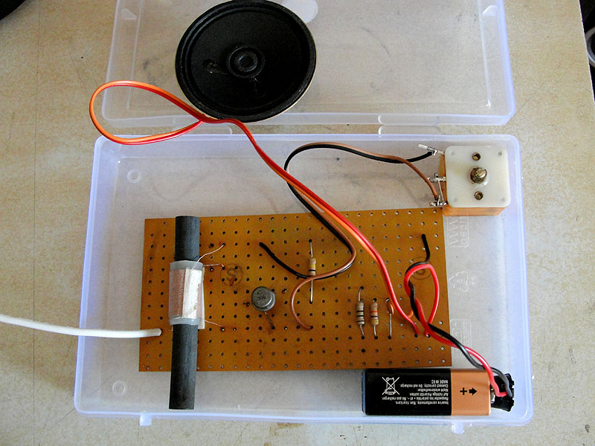

Antenna Wire [A plastic coated flexible electrical wire can be hanged outside the house in open space. Longer the wire better will be the performance and range of the transmitter]

The Kit after final assembling

Component identification

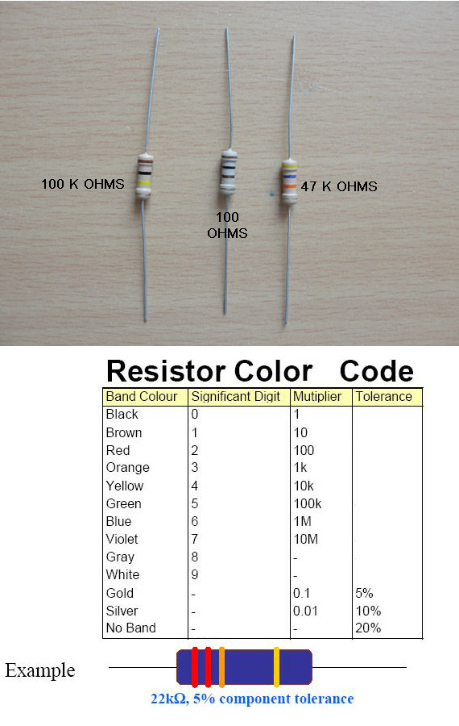

Carbon Resistors [ The Sequence of letter remembered by generations of students by the mnemonic:
B B ROY GOOD BOY VERY GOOD WIFE [ W – white ]

Disc Ceramic Capacitor

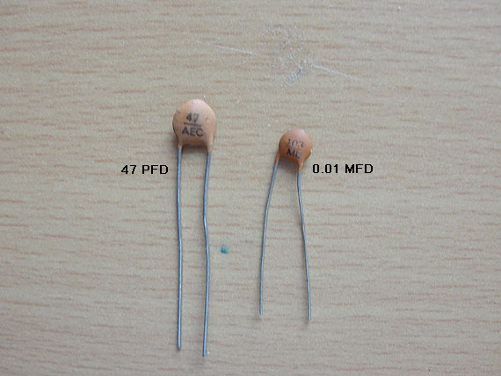

Capacitors below 1000 pF [ picofarad ] value are inscribed with it value. The Capacitor on the left is 47 pico Farad [ pF ]

Capacitors from an above 1000 pF are either color coded or the value is represented by three digits.

The capacitor on the right is inscribed ‘ 103’
[ meaning 0.01 micro Farad – mFd ]

How to read Capacitor values?

1000 pF and above > 3 Digit Code

1 0 3
| |--Decimal multiplier
|
Represent the ‘two’ significant digits
103 > 10 x 10³ = 10,000 pF > 10 KpF
We can express 10,000 pF in microfarad [µF micro means 10⁻⁶ ] i.e.

10,000
1000000 = 0.01 µF
Simple method:
104 0000104 = 0.1 µF
103 0000103 = .01 µF
102 0000102 = .001 µF
403 0000403 = .04 µF

Identifying Semiconductor Transistor leads

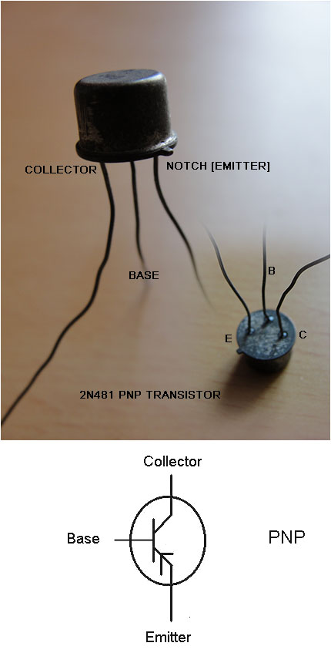
The supplied transistor is 2N481 PNP type. Don’t connect battery polarity wrongly as that can damage the transistor after you finish assembling the kit
Placement of the components on the General Purpose PCB [ Printed Circuit Board ] as the Circuit diagram Schematic.
0.01 mFd
Double Stranded will come here

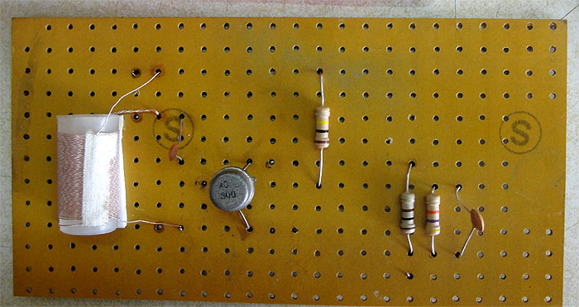
100 k
E
C

47 pF
47 Kilo Ohms
100 Ohms
Base of Transistor

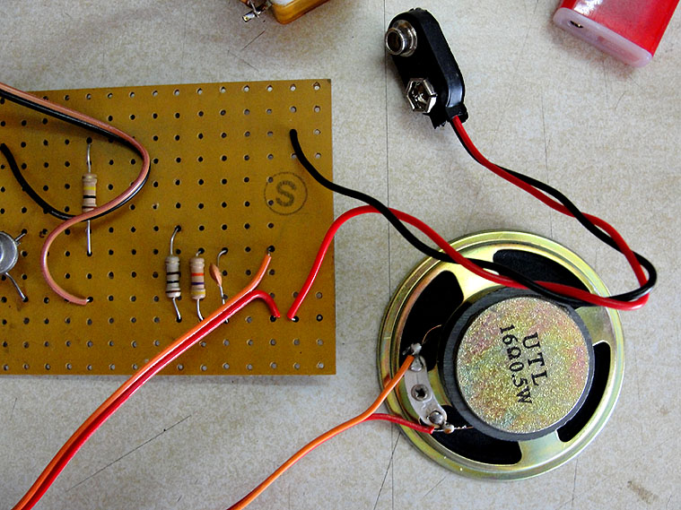

9 Volt +ve

Soldering components

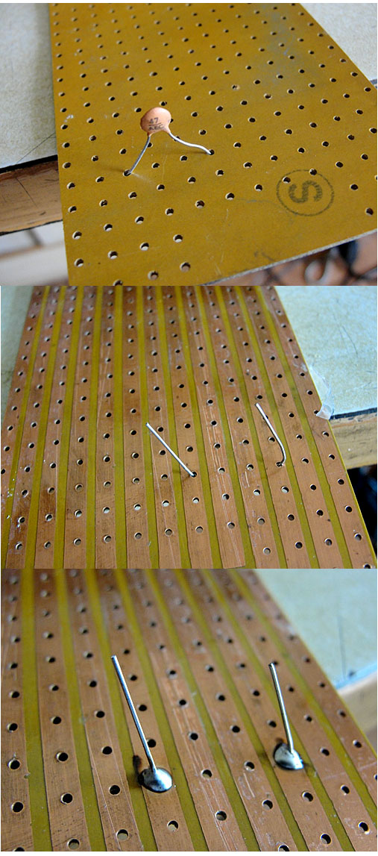

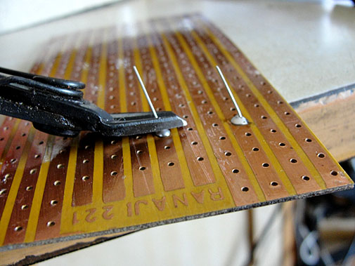

Use a cutter to strip off extra leads

The Final assembled kit.
Observe the connections carefully

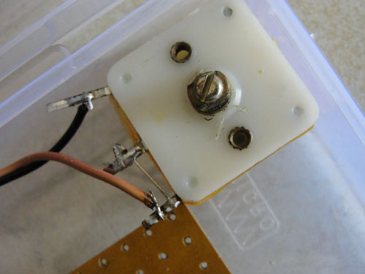

These two shorter leads of the Plastic PVC 2J Variable Gang Capacitor are ‘shorted’

Home Broadcasting Radio Station

List of components:

- Transistor : 2N481 (PNP)
- Inductor : MW antenna coil on ferrite rod
- Variable capacitor : PVC 2J (500 pF) single gang capacitor
- Resistors : R1 = 100 Kilo Ohms (1/2 Watt)
R2 = 100 Ohms (1/2 Watt)
R3 = 47 Kilo Ohms (1/2 Watt)
- Capacitors : C1 = 0.01 mFd (microfarad) disc ceramic
C2 = 47 pF (picofarad)
- Loudspeaker : 8 Ohms (500 mw)
- 9 Volt Battery
- General purpose Printed Circuit Board (PCB)
- Soldering iron 10/15 Watts
- Solder and flux
- A Medium Wave Radio Receiver to listen to your transmission.

The project shown here is of a ‘Home Broadcasting radio Station’ or you can call it a toy transmitter. In this modern age of electronics we can make good hobbies with electronics and learn at the same time the fundamentals of the electronics.
This simple model of toy transmitter is aimed basically at introducing to the learners about how wireless communication works.
The minimum range of the transmitter to be constructed is about 100 ft.. The range can be increased to about 200 ft. if suitable transmitting antenna is used. Send your voice or your pre-recorded voice and if your A.M. Radio is set to the proper tuning point, it will pick up the sound of your voice.

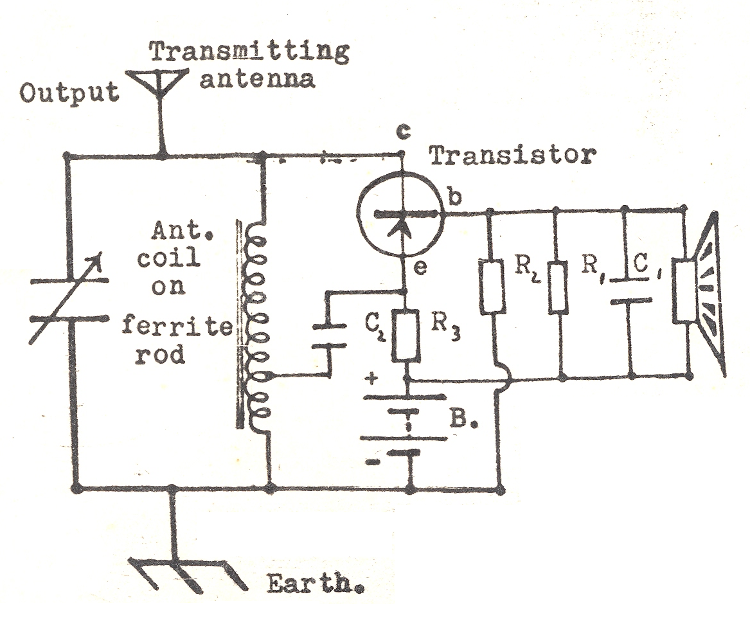
(Refer to our course material for detailed information about the electronic components used in this project)

Theory of operation:

- The sound waves are converted to equivalent Pulsating Audio Electrical Cureents.
- The transmitter generates Radio Frequency (RF) Currents.
- Pulsating Audio signals are mixed with RF currents.
- Radio Frequency currents superimposed with audio signals are radiated by the telescopic transmitting antenna in the form of electromagnetic wave.

Converting of voice (sound waves) to Audio Frequency (AF) currents

The loudspeaker (8 ohms) in this circuit works like a microphone. Microphone is a device which converts sound waves into electrical impulses (electrical currents).
The microphone is based on the principle of electromagnetic induction. It consists of a small coil (voice coil) attached to a freely moving paper cone, called diaphragm. The coil is situated in the magnetic field of the permanent ‘pot’ magnet. The sound waves in front of the diaphragm cause the diaphragm to vibrate along-with the voice coil. Thus an ‘induced pulsating current’ is produced in the coil, which is alternating in nature (Alternating Current). The flow of an electric current through a wire creates a circular magnetic field around the wire. This magnetic field has the highest intensity near the conducting wire and the intensity gradually decreases as the distance from the wire increases. If a straight conducting wire is made into a loop giving it a ‘coil’ shape, the small magnetic loops around the wire overlap each other resulting in a more stronger magnetic field around the whole coil. The strength of the magnetic field depends on the number of turns in the coil, amount of current in the coil and the permeability of the core material. Air has a permeability of 1.

Mixing of Audio Frequency with Radio Frequency

The aim of our project is to generate radio frequency which would carry audio information to a listener at a distant place. This simple process of mixing audio and radio frequency is called ‘modulation’. The audio signals are very weak and hence is carried to the transistor 2N481 (transistor is a semiconductor device). In this circuit, the semiconductor device is constantly amplifying the weak audio signals and mixing them to radio frequency currents. This circuit generates Amplitude Modulated Radio Frequencies. Amplitude Modulation (AM) is a process in which the amplitude of a radio frequency current is made to vary and modify by impressing an audio frequency current on it. A radio frequency current has a constant amplitude in absence of modulation and this constant amplitude RF carries no information, i.e. no audio intelligence and is of no use to radio telephone (voice communication), but has application in morse code communication.
So, to give intelligence to the RF current, audio signal is impressed/superimposed on the RF current in a non-linear modulator circuit; as a result of which carrier current amplitude begins to rise to a maximum value above and below its original amplitude during the positive cycle of the audio signal and during the negative cycle of the audio signal, it falls to a minimum value.

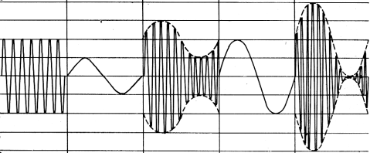
Unmodulated 50% Amplitude of 100%
RF Carrier Audio signal modulated audio signal modulated
Carrier is increased carrier

This results in the carrier having two outlines of the audio signal, this is because the variation at instant in the amplitude of the carrier wave is directly proportional to the value of the modulating signal.

Generating Radio Frequency

The device used to generate radio frequency current is defined as “Oscillator Circuit”. Here, the transistor functions as a Radio Frequency Oscillator in combination with the ‘Inductor’ and the ‘Variable Capacitor’. The frequency at which the transistor circuit oscillates is determined by setting of the ‘Variable Capacitor’ as it functions in combination with the ‘Antenna Coil’, i.e. inductor coil. The combination of the inductor coil and the variable capacitor is called a ‘Tank Circuit’, which in turn transmitting the RF Signals through the wire antenna.

How an oscillating circuit works?

As we know that the transmitter generates Radio Frequency Currents (Frequency is only due to oscillations of electric currents, and in case of Radio Waves it is very high; like 729000 Hertz or say 14000000 Hertz and so on per second). This tiny transmitter with only one transistor is also generating high frequency currents.
Electrical Oscillation means rapid to and fro motion of electrons or electric currents. As oscillating current is generated in the transmitter, you may imagine that the ends of the antenna system are charging with opposite polarity momentarily, resulting the radiation of Electromagnetic Waves (i.e RF waves) far into the space surrounding the antenna. The simplest oscillator circuit is shown below. It is a combination of a capacitor and a coil (Inductor).
A basic oscillator which can produce oscillations at a particular frequency consists of a capacitor, a coil (inductor) and a DC voltage source along with a switch as shown below.
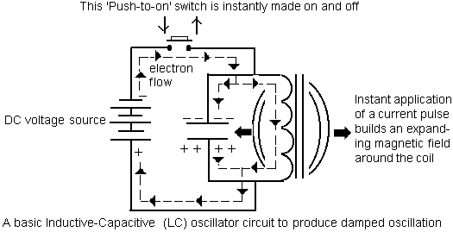

By making the switch ‘ON’ instantly and then releasing it to make ‘OFF’, a pulse of current finds it path to the capacitor as well through the inductor resulting in an expanding magnetic filed across the inductor while charging the capacitor simultaneously. The instant when the switch is made ‘OFF’, the capacitor discharges releasing the extra electrons on the top plate through the inductor to reach the other plate. The current thus produced is in the same direction as when the switch was made ‘ON’. Thus it aids to maintains the expanding magnetic field produced during the instant when the switch was made ‘ON’. The capacitor will reach a neutral state after the electron from the top plate neutralizes the bottom plate (the positively charged plate), i.e. the capacitor will be getting discharged in the process. As there is no supply of electrons from the DC voltage source (because the ‘switch’ is ‘OFF’), and the capacitor is also fully discharged, so, the magnetic field around the inductor will now collapse resulting in a self-induced voltage. This self-induced voltage will make enough current to flow through the inductor to charge the capacitor in opposite direction. A similar process described above will now start and repeat over and over again producing damped oscillating currents until all of the energy is wasted by circuit resistance and other losses. This is called the ‘flywheel effect’. It is similar to what happens when a pendulum is started in motion. It tries to continue swinging at the same frequency until all of the starting energy is used up. The unique thing to notice here is that oscillations will maintain a particular frequency despite loosing their amplitude. This frequency is called the resonant frequency and the circuit described above is called a tank circuit. The frequency of resonance can be found from the formula:

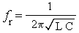

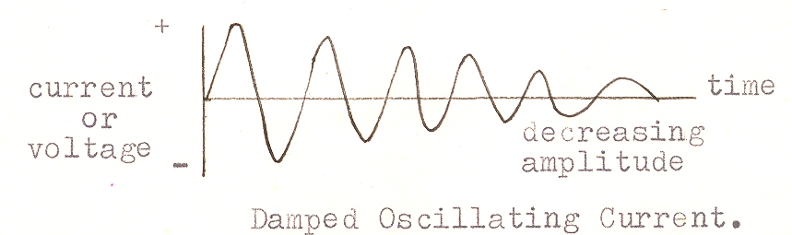

In the electronic circuitry, a damped oscillation is not at all desirable from the practical utility point of view. So, the objective is to use a transistor provide the necessary gain (and not loss!) and feedback (the energy) to sustain the oscillations or to produce perfect sine wave frequency.

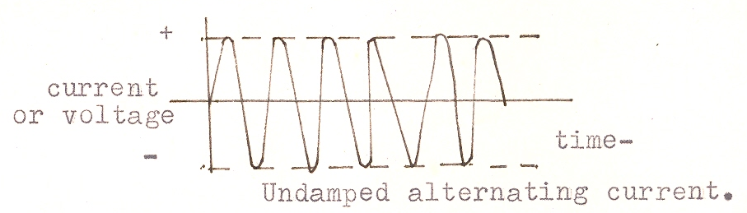

In our transmitter circuit the transistor 2N481 provides the feedback energy.

Transmitting the Radio Frequency currents

To transmit radio frequency currents superimposed with audio information in the form of electromagnetic radiation, we need a device called ‘Antenna’. Aerial or antenna is a device, which acts as the mouth and ear of a radio transmitter or receiver respectively. Though we don't notice any external aerial in many of the commercial radio sets, they in fact, have aerials in built within the cabinets holding their electronic circuitry. The aerials are usually made out of metallic rods or wires which are cut into specific lengths. The aerial should not be placed behind any obstruction, conducting materials such as tin-roof, ferro-concrete and to lesser extent foliage when wet. The aerial should be as high as practical above the ground and grounded objects such as metal roofs, power or telephone wires etc.
Unless there are some types of radiating devices, the RF currents with audio information would not be converted to electromagnetic radiation. Antenna is a device which converts RF currents into electromagnetic radiation and make them travel in space. There are various technical aspects of antenna designing. A simple antenna is a long wire antenna which may be just hanged outside our house. The length of antenna depends of the wavelength of the radio frequency.
We can use a simple long wire (plastic insulated conducting wire commonly available in electrical shops)

Receiving the radio transmission
In a radio receiver, the selection of the desired frequency out of hundreds of other frequencies is achieved by the use of resonant circuit. The resonant circuit basically consists of an inductor and a capacitor. The frequency of resonance is usually achieved by changing the capacitance of the variable capacitor.

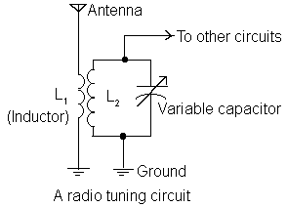

In the tuning circuit shown above, all the frequencies captured by the antenna are passed to ground through the primary coil L₁. They will try to cause current flow in the tank circuit, but only the resonant frequency will be successful in creating a current flow. The information it carries will be sent to the other radio circuits while the non-resonant frequencies are practically ignored. In the circuit shown above, the condition of series resonance is present but is not apparent. In this circuit the transformer secondary coil has a capacitor across it with a reactance of the secondary, forming a resonant circuit. At first glance it appears to be a parallel-resonant circuit. The primary coil, however, is inducing an AC voltage into each turn of the secondary coil. Theoretically, the secondary may be considered to have a source of AC inserted in series with its turns. The ordinary Medium Wave Radio Receiver you are using also contains a similar circuit inside. Carry your transmitter near your radio receiver. Fix the tuner of the radio receiver on a point where you do not hear transmissions from other radio station. Now switch on your transmitter. Slowly adjust the Variable Capacitor of the transmitter. At a point you would hear a loud shrieking tone in the radio. This means both your receiver and transmitter are aligned at a single frequency. Now adjust the position of the coil on the ferrite rod, so that maximum sound is obtained. Now take the transmitter away from your receiver and speak in front of the microphone. You can listen to your voice on the radio!

Dedicated to my Dad
[ Here are my dad’s handwriting in 1983 – a warning note not to distract away from my ‘real studies’ ]
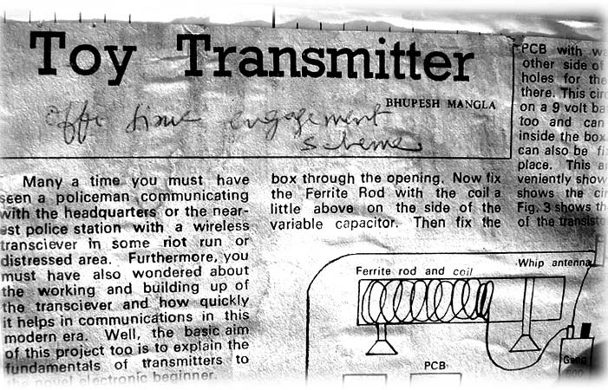

Have fun and enjoy learning
Best Wishes

Sandeep Baruah VU2MUE
sandeepbaruah@gmail.com
http://www.riverdevil.org

